Table of content

1 Introduction 2

2 Background and terminology 2

2.1 Neural Networks 2

2.1.1 CNN 2

2.1.2 BNN 2

2.1.3 RNN 2

2.2 Hardware 2

2.2.1 FPGA 2

2.2.2 Google Coral dev board 2

2.2.3 Raspberry Pi 2

2.2.4 Summary of hardware specs 2

3 Method 3

3.1 Comparison 3

3.2 Models/networks used 3

3.3 Datasets 3

3.4 Implementation 3

4 References 4

# Introduction

Background, recent spike in interest, motivation, future possibilities, thesis outline

# Background and terminology

## From AI to NN

AI is a name for everything we consider to be intelligent and that can be implemented artificially.

Machine learning is the part of AI where the machine takes on the actual learning about the world around us and then puts that learning into good use.

Neural networks are one method for realizing Machine learning. Inspired by how the neurons and synapses in a brain functions, neural networks use the same general idea.

gsdgsdfgsfsfhsfh

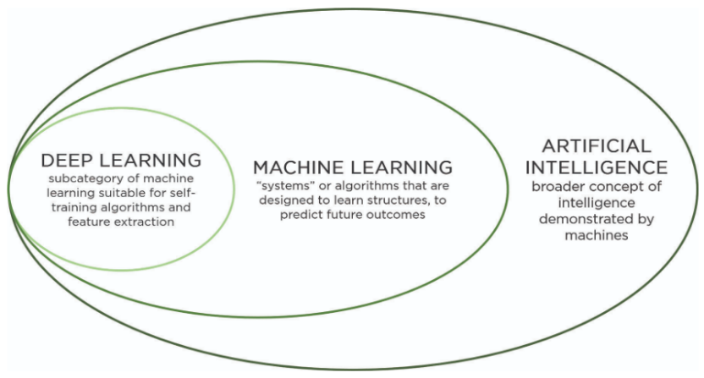

Figure 1. Figure showing the relationship between AI, Machine Learning and Neural Networks.

gsdgsdg

## Neural Networks

Training vs classification/inference

Batching, what is it used for?

### CNN

Convolutional layer, pooling layer, FC layer, weights, activation function, eBNN.

### BNN

What makes a network binary, pros and cons, reference previous research

### RNN

How does it work and what is it used for?

## Hardware

### FPGA

### Google Coral dev board

### Raspberry Pi

### Summary of hardware specs



Figure 2. Summary of hardware specs.

# Method

## Comparison

## Models/networks used

### AlexNet

### GoogLeNet

### VGG

### YOLOv3

## Datasets

## Implementation

# References

|  |  |
| --- | --- |
| [1] | M. Courbariaux, I. Hubara, R. El-Yaniv och Y. Bengio, ”arXiv.org,” 17 Mars 2016. [Online]. Available: https://arxiv.org/pdf/1602.02830.pdf. [Använd 13 09 2019]. |
| [2] | B. McDanel, S. Teerapittayanon och H. Kung, ”Embedded Binarized Neural Networks,” i *International Conference on Embedded Wireless Systems and Networks*, Uppsala, 2017. |